All answers are to be validated through appropriate SQL or PL/SQL code. **(Show all your work: structured query code & output for full credit)**

(1) Create a view that will display employees with employee id > 150 from the employees table.

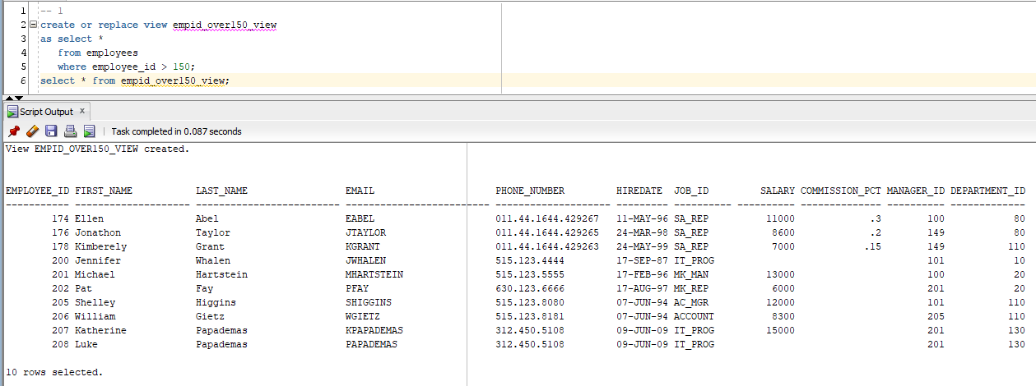

(2) Create autosequence named **auto_id_seq**. The **auto_id_seq** should have a start value of **250** and is auto set to increment by **1** every use. The max set for the sequence is **1000**. Create a new column call **auto_id** for the employees table. Insert a new record into the employees table with following information. Let auto_id be populated with the next value available from **auto_id_seq**. Extra credit: place your name as the next record.

|  |  |  |  |  |  |  |  |  |  |  |
| --- | --- | --- | --- | --- | --- | --- | --- | --- | --- | --- |
| Auto  _id | Employee_id | First  _name | Last_  name | email | Phone_  Num | Hire  _date | Job_id | salary | Commission_pct | Manager  _id |
|  |  |  |  |  |  |  |  |  |  |  |
| 250 | 151 | Joseph | King | JKING | 515.123.4567 | 07-18-13 | COOK | 10000 |  | 100 |
|  |  | Papademas | Katherine |  |  |  |  |  | 0.25 | 100 |

**Create sequence and view its information:**

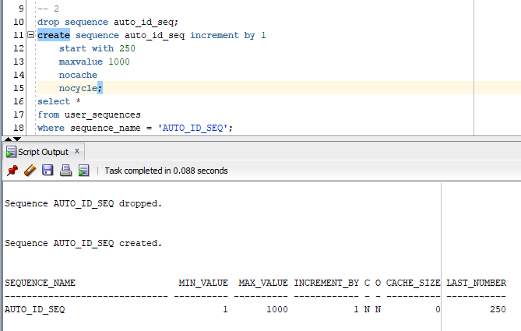

**Create new column:**

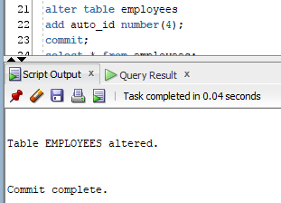

**Insert 2 records using the sequence:**

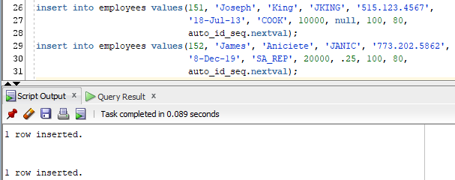

**Resulting employees table:**

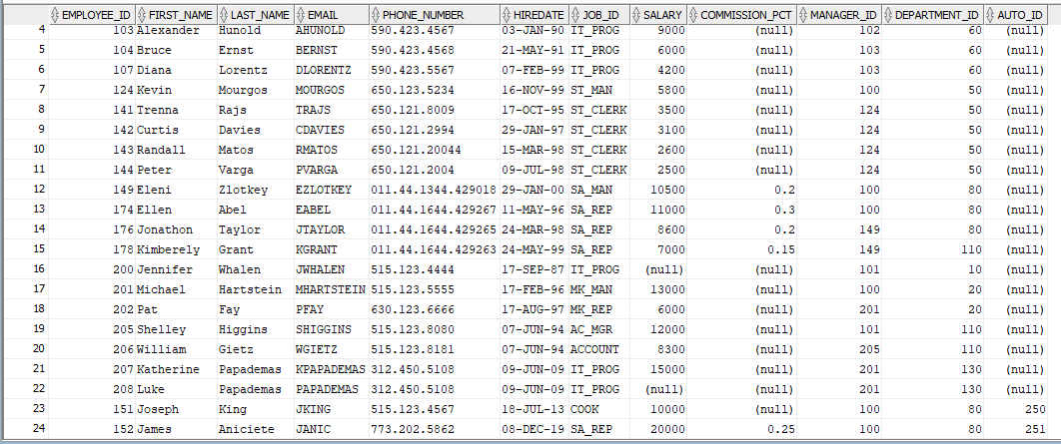

(3) Show the result returned by the following character manipulation function.

SUBSTR('Roosevelt',INSTR('Roosevelt','v'))

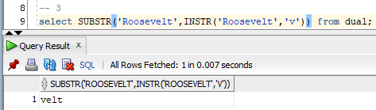

(4) Construct an SQL statement to assign file permission to “Plato” (LOGIN =FR8025)

so that he may gain read-only access to your *studentinfo* table.

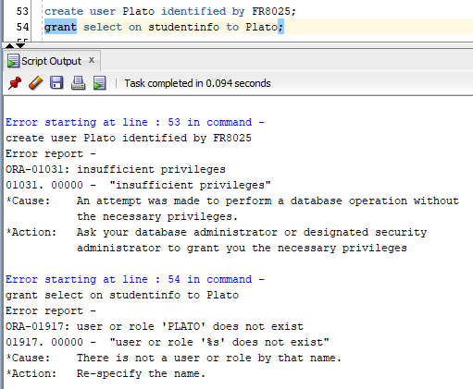

Questions 5-13 refer to the The50states.sql script. The script can also be located in the directory on campus from the path shown below:

**Go to Desire To Learn Course Shell for this course.**

1. Load the script “The50states.sql” and perform a top-n analysis that will give the state bird and the state flower for the original 13 states. The output should reflect a title of “Our United States” which is to be center justified. The bottom of the report should have your name and date. Note: If working with 11g (oraclecis.oakton), then ignore report requirements.

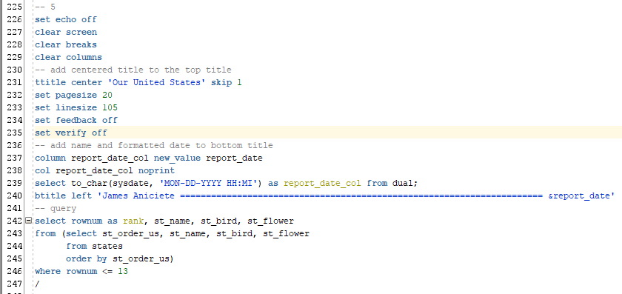

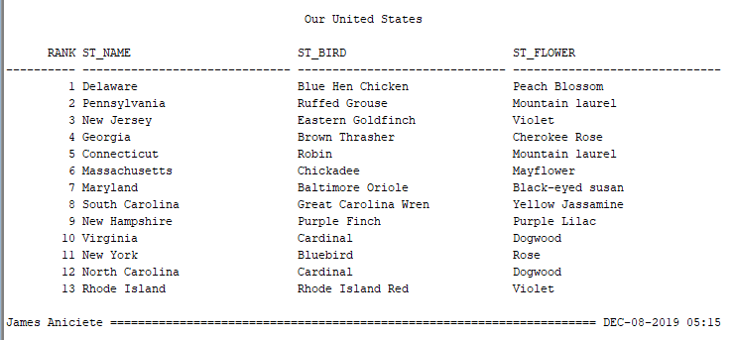

(6) Which states have the cardinal as their state bird? List them in alphabetical order.

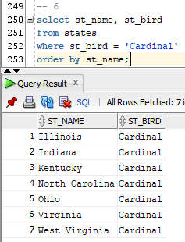

(7) How many states start with the letter “O”? Are the number of states that start with the

letter “O” more than, less than or equal to the states that starts with the letter “M”? Be sure

to show the code that reveals the answers.

**3 states start with the letter “O.” The number of states that start with the letter “O” are less than the number of states that start with the letter “M.”**

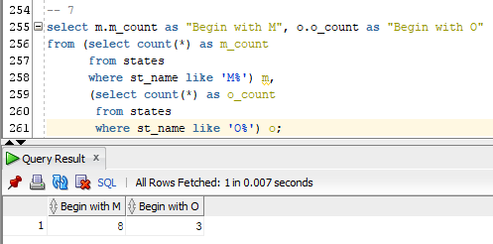

(8) List the states that do not have the “Western Meadowlark” or the “Cardinal” as their state

bird.

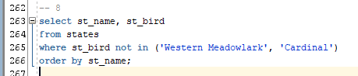

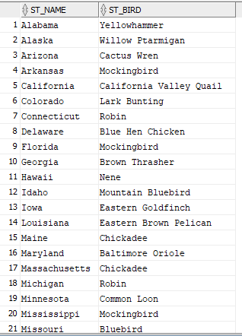

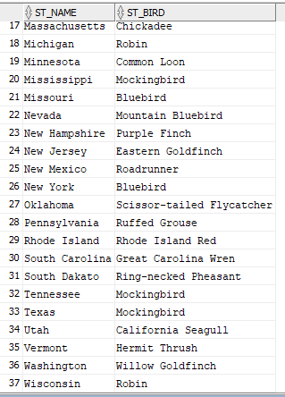

(9) What are the capitals of the following states: Illinois, Michigan, Indiana, Wisconsin,

Minnesota and Ohio?

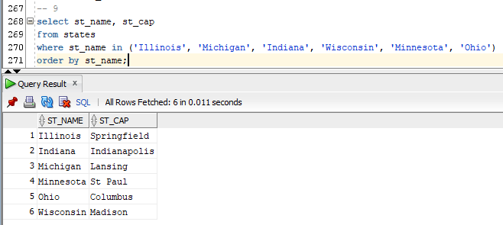

(10) Give a frequency count for the state birds.

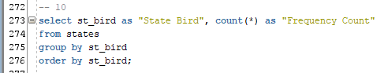

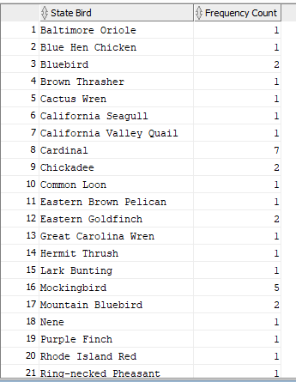

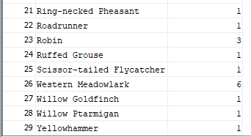

(11) What states were admitted into the Union between the 25th and 35th order of admission?

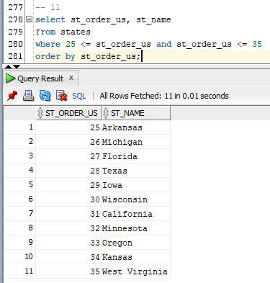

(12) Give the states whose capitals do not end with a vowel and whose state flower does not begin with a vowel.

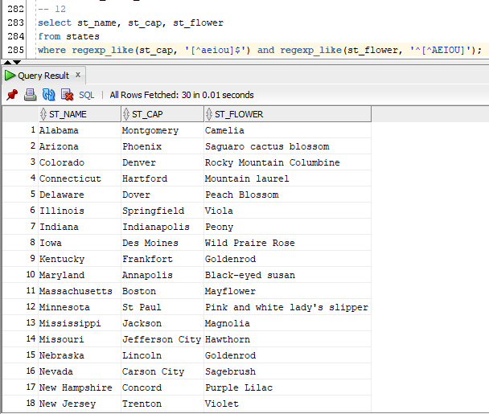

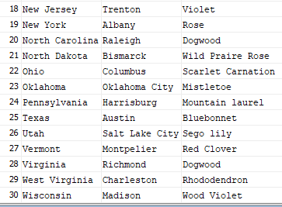

(13) Update the table with a new field “Gemstone” and update the field for the state of Illinois with the value “Fluorite”, for the state of Michigan with the value of “Chlorostrolite”, and for the state of Indiana with the value “Salem Limestone” and for the state of Wisconsin “No Official Gemstone.”

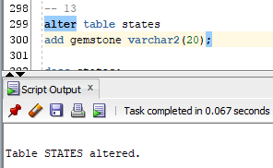

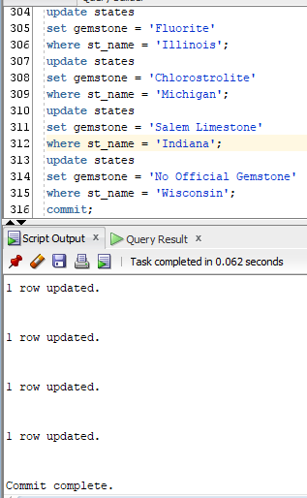

**Check:**

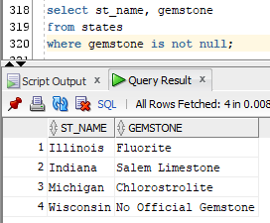

**PROJECT ONE using PL/SQL**

**Objective** To create and execute a logical PL/SQL program.

***PROJECT DESCRIPTION***

Sammy Moneybags, Sammy Student’s cousin, needs to convert US dollars to Canadian Dollars and to British Pounds. Write a program using PL/SQL to help Sammy enter in any US dollar amount and have output as Canadian Dollars and British Pounds.

***Information About This Project***

Use the following currency conversion factors for this problem:

1 US Dollar = **1.32551893 CAD (**Canadian Dollar) [as of December 8, 2019]

1 US Dollar = **0.76119346 GBP (**British Pound)

If you wish to have the latest conversion factor, visit the following website <http://www.xe.com/ucc/>

***Steps To Complete This Project***

**STEP 1** **Open PL / SQL on your Computer (Note: either use Marvin or SQL Developer for this project)**

Open Oracle SQL and type your **PL / SQL** program code which will perform the

currency conversion upon user input of a number of US dollars.

**STEP 2** **Run your PL / SQL Program Code**

Run the above PL/SQL program to convert the US currency for the following

amounts: $100, $1000, $10,000.

**STEP 3** **Take a Screen Snapshot of your SQL Program**

Once your program runs successfully, you will take a screen snapshot of your PL/SQL program and paste it into an MS Word document. Add your name, date and course information to your document and submit the hardcopy for credit.

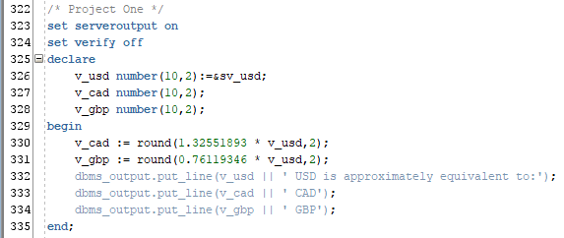

Note: to take a screen snapshot of your running program, use the keyboard shortcut Alt + Print Screen to capture your output, then open MS Word and

use the keyboard shortcut t Ctrl + V to paste the output into your word processing document.

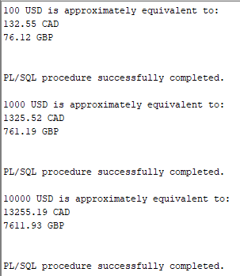

**PROJECT TWO – Using PL/SQL**

**Objective** To create and execute a logical PL/SQL program using selective control statements

***PROJECT DESCRIPTION***

Write a program that computes a salesperson’s commission according to the specifications outlined below.

A particular company computes a salesperson’s weekly commission as follows:

If the salesperson sold less than or exactly equal to $ 500 in

products / services, then the salesperson’s commission rate

is 4.00 %.

If the salesperson sold more than $ 500 but not more than $ 1,000

in products / services, then the salesperson’s commission rate

is 8.00 %.

If the salesperson sold more than $ 1,000 in products / services,

then the salesperson’s commission rate is 15.00 %.

To compute a salesperson’s commission, multiply the commission rate by his / her total sales.

***Information About This Project***

Program design is often accomplished using SQL, Structured Query Language.

***Steps To Complete This Project***

**STEP 1** **Open PL / SQL on your Computer**

Open Oracle SQL and type the required **PL / SQL** program code.

**STEP 2** **Run your PL / SQL Program Code**

Run the above SQL program by entering $ 5,000 for the sales and observe the output of the program. Run your program again by entering $ 500 for the sales and observe the result of your program.

**STEP 3** **Take a Screen Snapshot of your SQL Program**

Once your program runs successfully, you will take a screen snapshot of your SQL program and paste it into an MS Word document. Add your name, date and course information to your document and submit the hardcopy for credit.

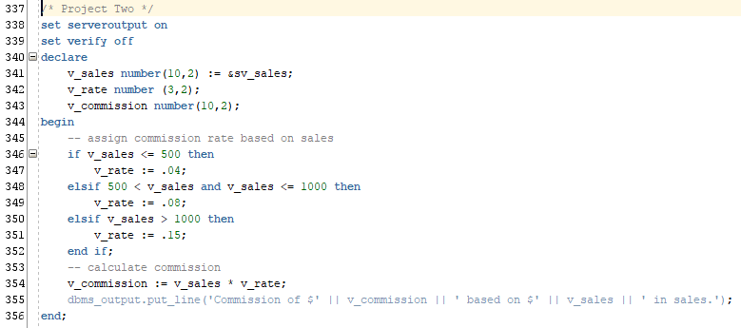

Note: to take a screen snapshot of your running program, use the keyboard shortcut Alt + Print Screen to capture your output, then open MS Word and

use the keyboard shortcut t Ctrl + V to paste the output into your word processing document.

